Tutorial

Prime:

1. Start your mysql database
2. Create a database named playdbtest
3. Change database password in conf/application.conf
4. Run run.sh in both frontend/ and backend/
5. Go to browser and enter http://localhost:8080

1. Forget password

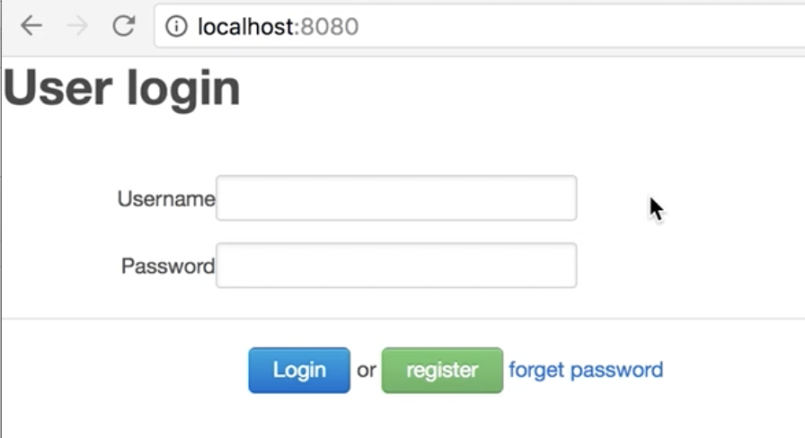

Click “forget password”

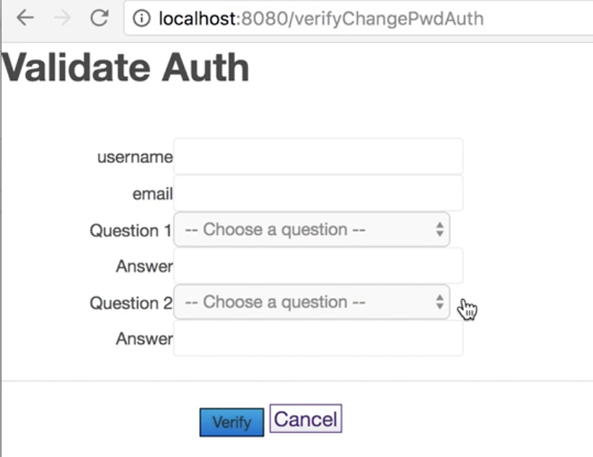

Then you will see the validation page for validating your personal information

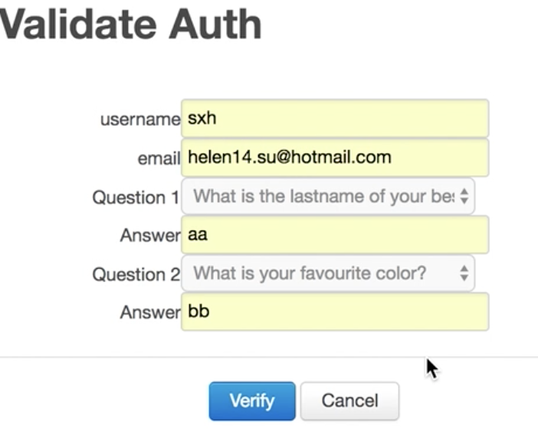

Enter the personal information answers and click “verify” and an email containing temporary password will be sent.

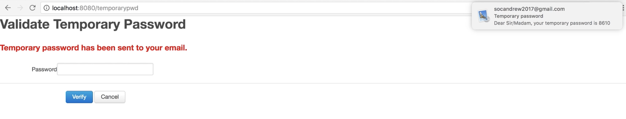

Enter the temporary password and you can change your password

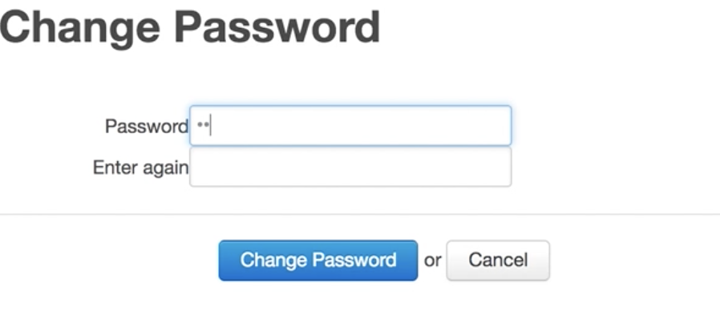

2. Admin page

\*Only admin have access to admin page. You can login as admin using username ‘sxh’ and password ‘123’

To enter the admin page

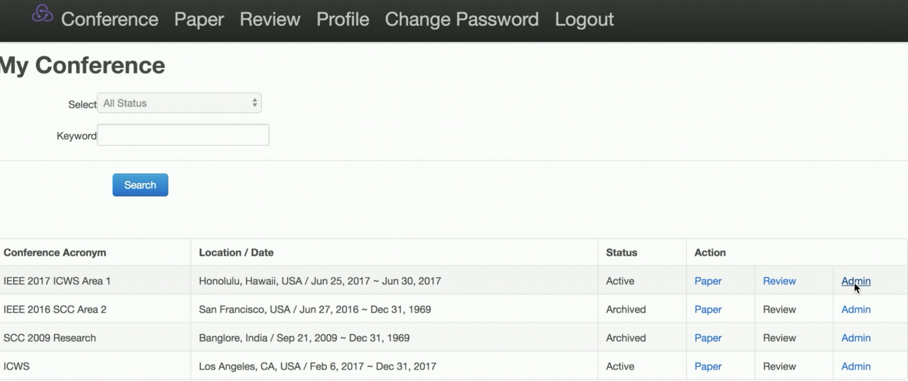

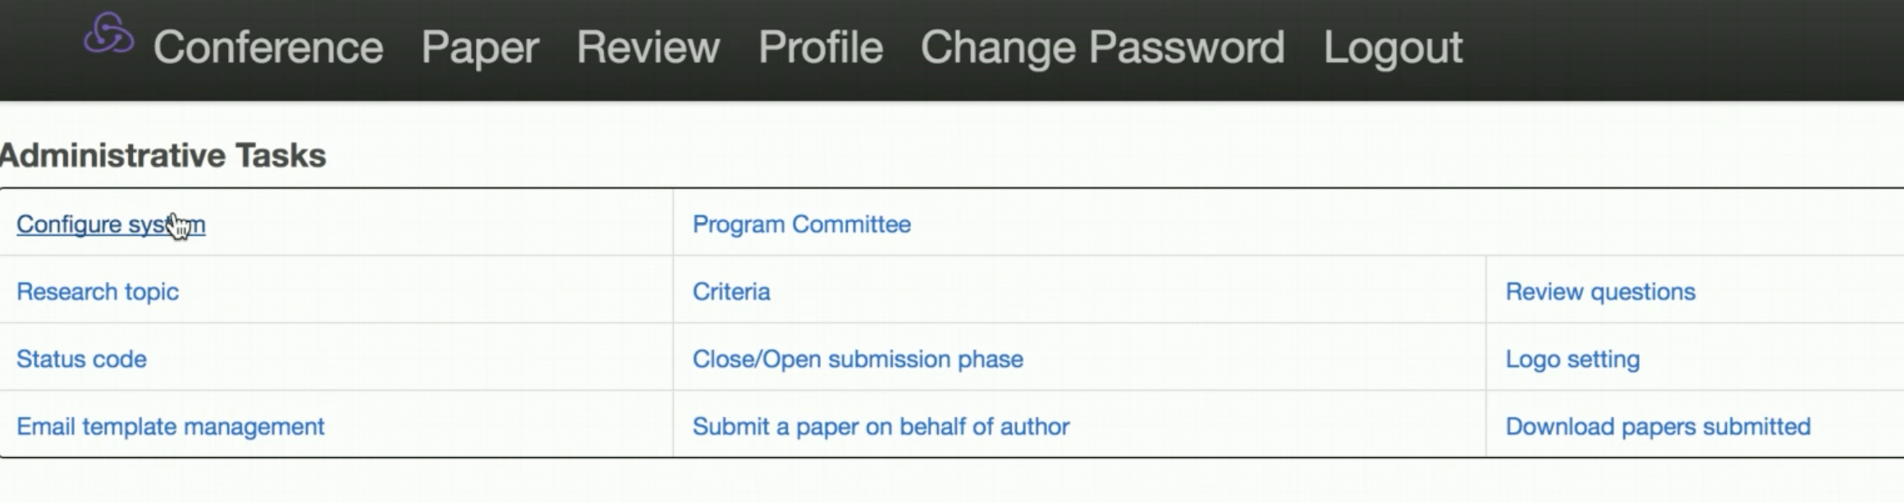

Configure system

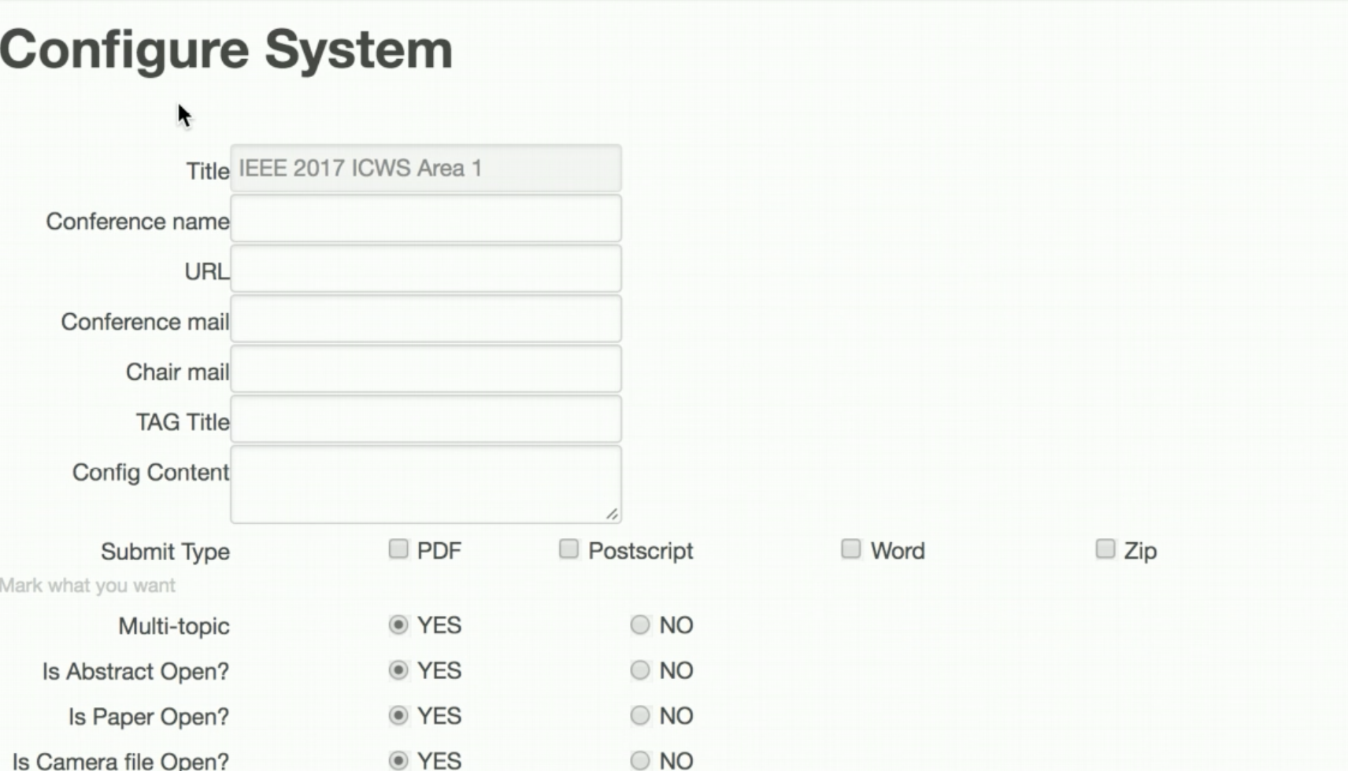

Manage PC member

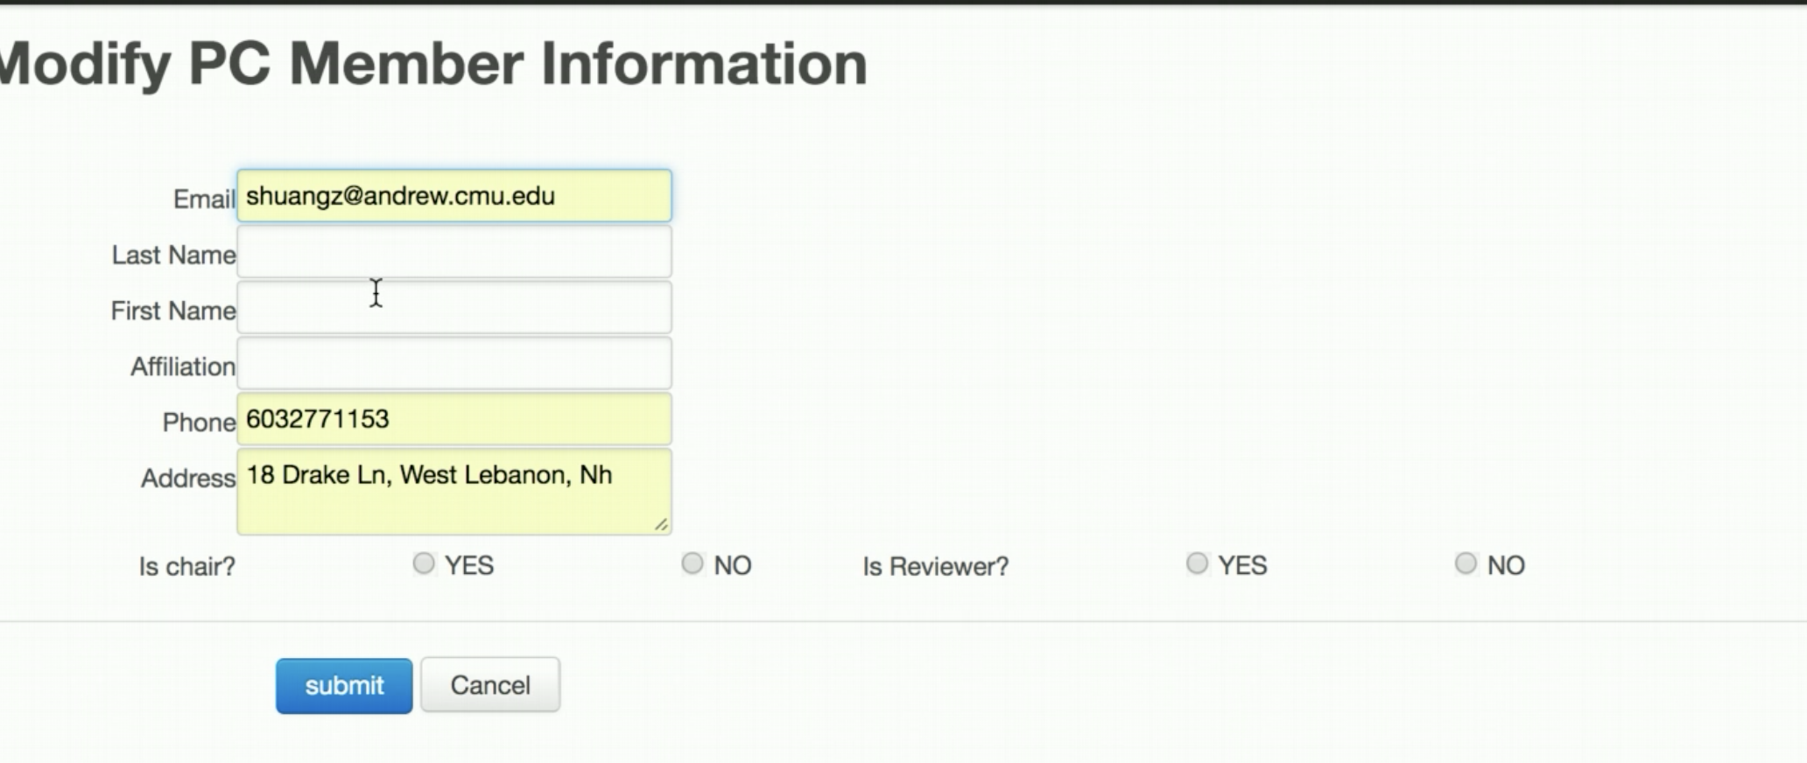

Set research topic

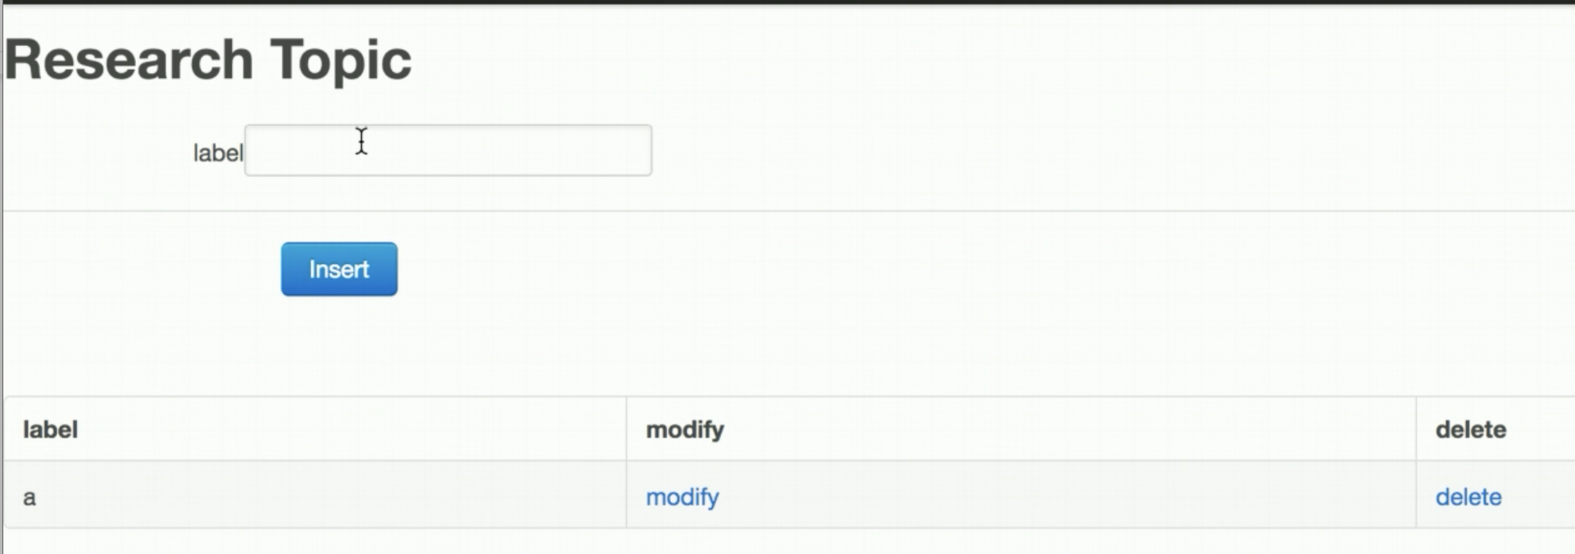

Add criteria

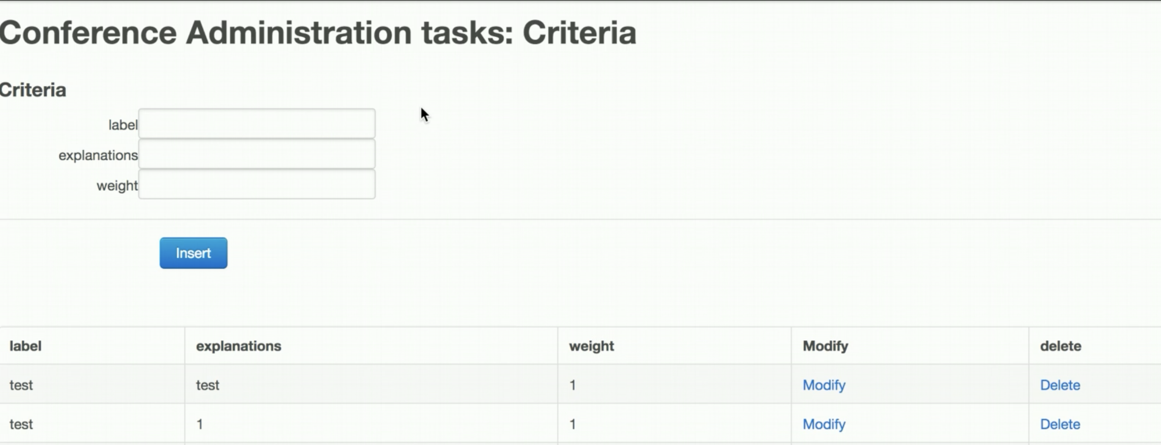

Add review question

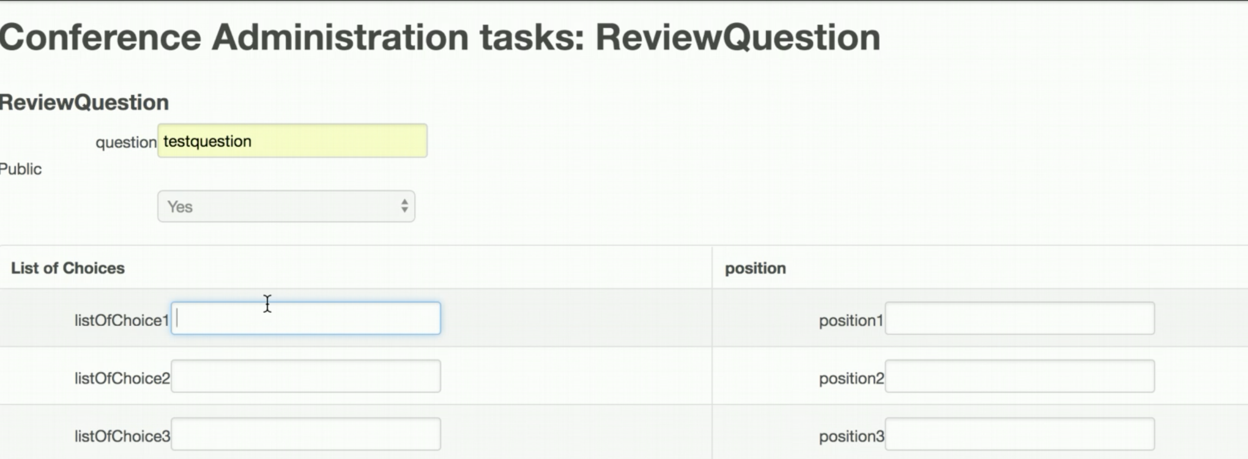

Status code

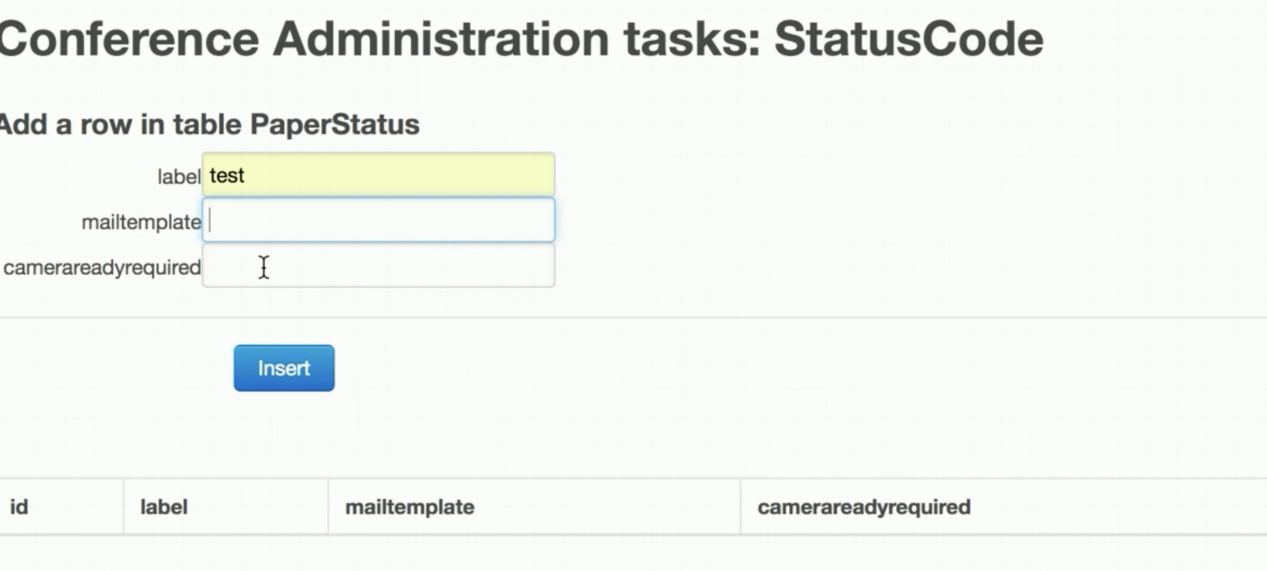

Email template management

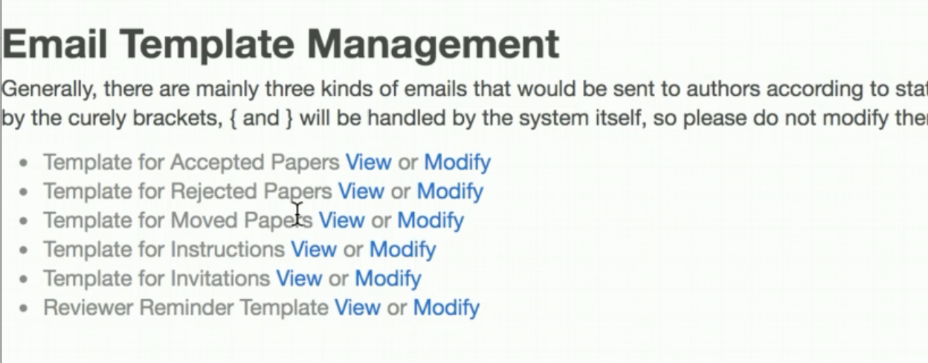

List of authors

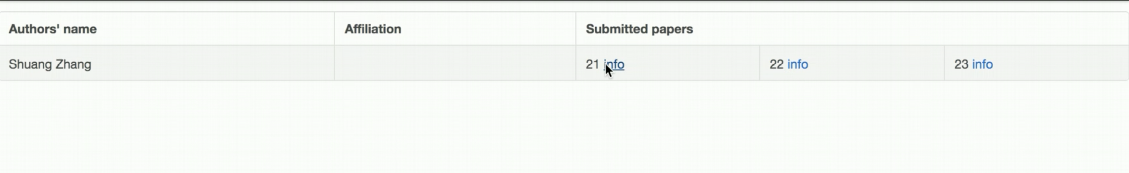

2. Submit a paper

To submit a paper, click ‘paper’ on nav-bar. Select a conference and click ‘create a paper’

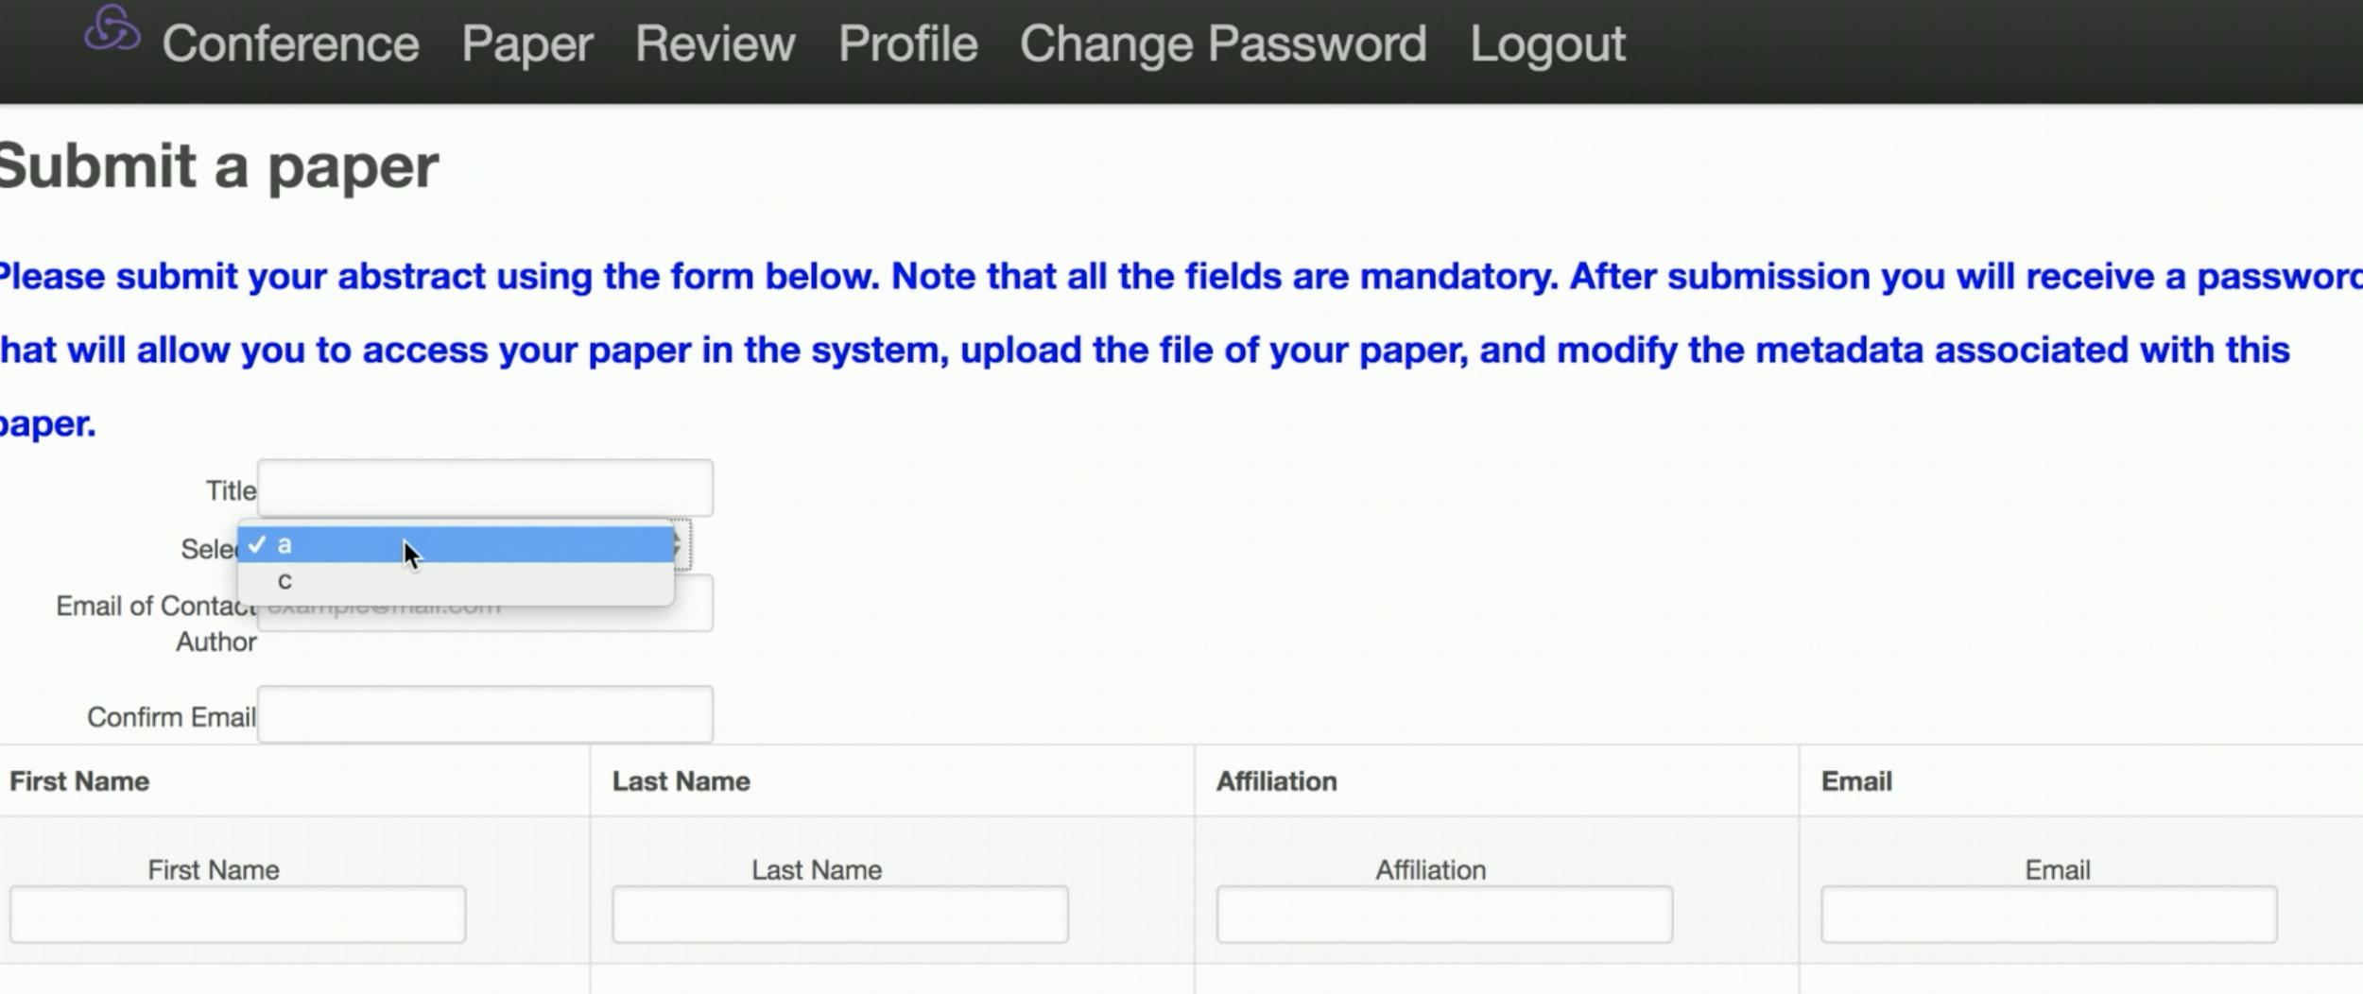

3. Review a paper

To review a paper(you should be a reviewer), click ‘review’ on nav-bar

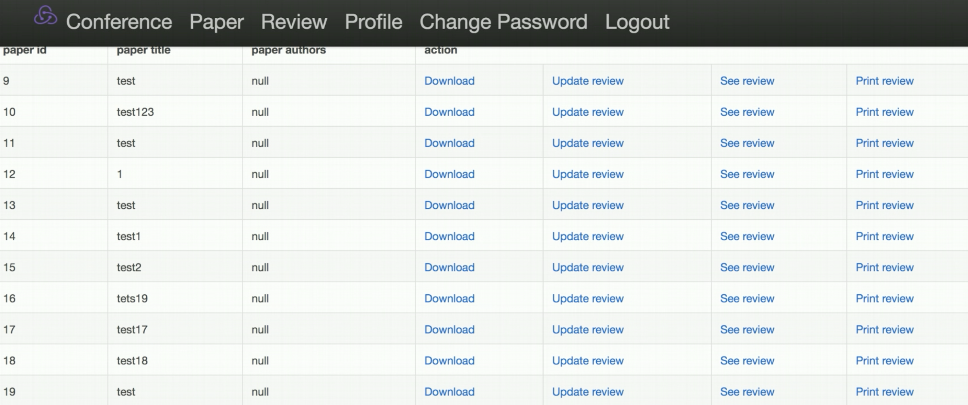

4. Assign a paper to a reviewer(manual assignment)

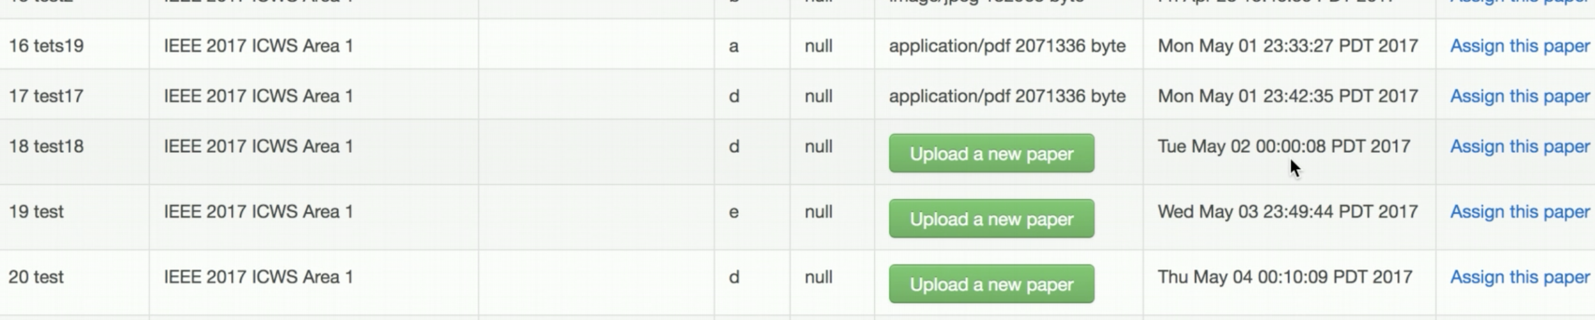

Click assign this paper

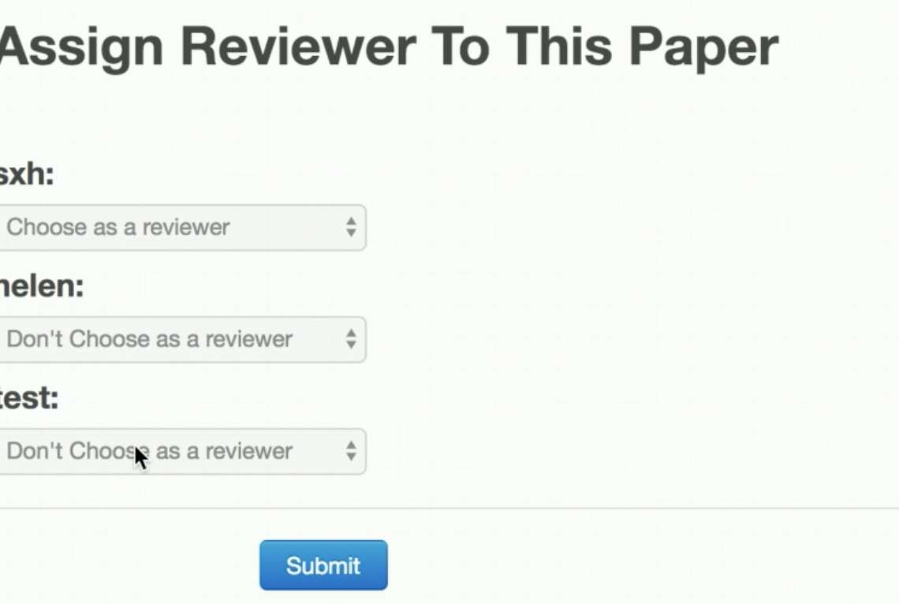

5. Profile

Click ‘profile’ on nav-bar

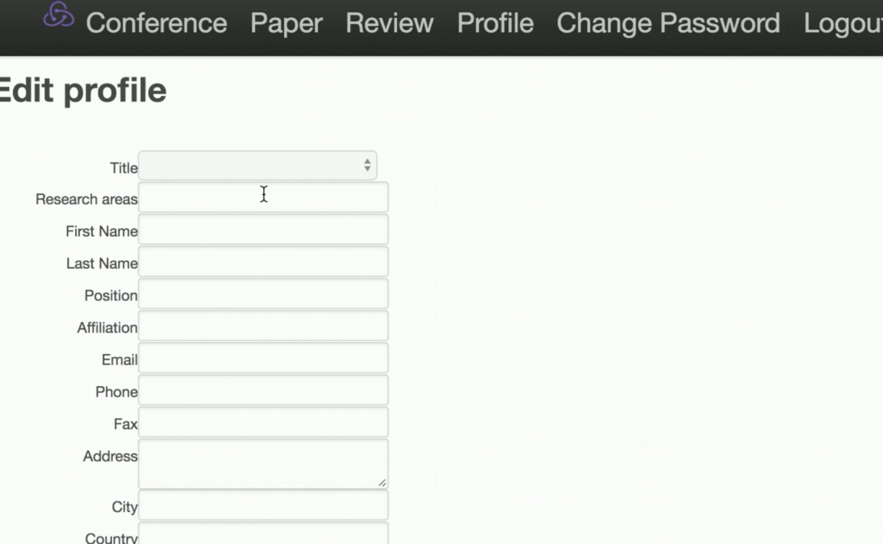

We only show the major functionalities here. For other small features, we think they are easy to use thus not show here.